Horizontal Guidance
You can receive horizontal guidance relative to the following design features:
- Lines within Office Designs or Infield Designs
- Design surface boundaries
- Setting a horizontal offset moves the horizontal guidance away from the selected line. You
- Add or subtract an offset square to the selected horizontal line.
Note- Design must have linework present for this functionality to be available
1. Access the Horizontal Guidance screen.
Method 1
Touch and hold the horizontal offset field in the guidance bar
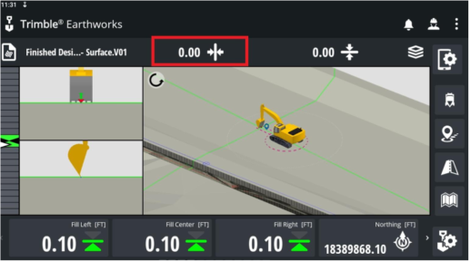
2. Select a line for horizontal guidance and select Apply.
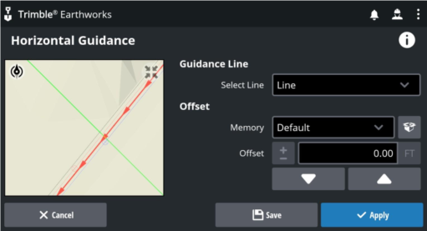
Method 2
Alternatively, you can also select a line for horizontal guidance from the context menu in the work screen:
1) From the plan view guidance pane, press and hold anywhere near the line you want to select. A context menu appears.
2) Tap Select 2D Line and select an available line.
3) Tap Horizontal Guidance.
Apply a horizontal offset:
1. Once inside the Horizontal Guidance Menu, Select a line to guide to.
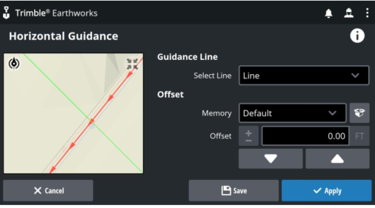
2. Enter the value of the offset or tap the up or down buttons to increase or decrease the value.
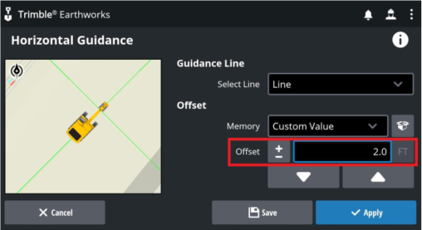
Note- To save this as a memory, tap Save.
3. Tap Apply

